Data Analysis of Ola Ride Bookings Using SQL and Power BI

SQL Answers:
1. Retrieve all successful bookings:
SELECT * FROM bookings WHERE Booking_Status = 'Success';
2. Find the average ride distance for each vehicle type:
SELECT Vehicle_Type, AVG(Ride_Distance) as avg_distance FROM bookings GROUP BY Vehicle_Type;
3. Get the total number of cancelled rides by customers:
SELECT COUNT(*) FROM bookings WHERE Booking_Status = 'cancelled by Customer';
4. List the top 5 customers who booked the highest number of rides:
SELECT Customer_ID, COUNT(Booking_ID) as total_rides FROM bookings GROUP BY
Customer_ID ORDER BY total_rides DESC LIMIT 5;
5. Get the number of rides cancelled by drivers due to personal and car-related issues: SELECT COUNT(*) FROM bookings WHERE cancelled_Rides_by_Driver = 'Personal & Car
related issue';
6. Find the maximum and minimum driver ratings for Prime Sedan bookings: SELECT MAX(Driver_Ratings) as max_rating, MIN(Driver_Ratings) as min_rating FROM bookings WHERE Vehicle_Type = 'Prime Sedan';
7. Retrieve all rides where payment was made using UPI: SELECT * FROM bookings WHERE Payment_Method = 'UPI';
8. Find the average customer rating per vehicle type:
SELECT Vehicle_Type, AVG(Customer_Rating) as avg_customer_rating FROM bookings
GROUP BY Vehicle_Type;
9. Calculate the total booking value of rides completed successfully:
SELECT SUM(Booking_Value) as total_successful_value FROM bookings WHERE
Booking_Status = 'Success';
10. List all incomplete rides along with the reason:
SELECT Booking_ID, Incomplete_Rides_Reason FROM bookings WHERE Incomplete_Rides =
'Yes';

Retrieve All Answers
#1. Retrieve all successful bookings:
Select * From Successful_Bookings;
#2. Find the average ride distance for each vehicle type: Select * from ride_distance_for_each_vehicle;
#3. Get the total number of cancelled rides by customers: Select * from cancelled_rides_by_customers;
#4. List the top 5 customers who booked the highest number of rides:
Select * from Top_5_Customers;

#5. Get the number of rides cancelled by drivers due to personal and car-related issues:
Select * from Rides_cancelled_by_Drivers_P_C_Issues;
#6. Find the maximum and minimum driver ratings for Prime Sedan bookings:
Select * from Max_Min_Driver_Rating;
#7. Retrieve all rides where payment was made using UPI:
Select * from UPI_Payment;
#8. Find the average customer rating per vehicle type:
Select * from AVG_Cust_Rating;
#9. Calculate the total booking value of rides completed successfully: Select * from total_successful_ride_value;
#10. List all incomplete rides along with the reason:
Select * from Incomplete_Rides_Reason;

Power BI Answers:
1. Overall
- Ride Volume Over Time
- Booking Status Breakdown
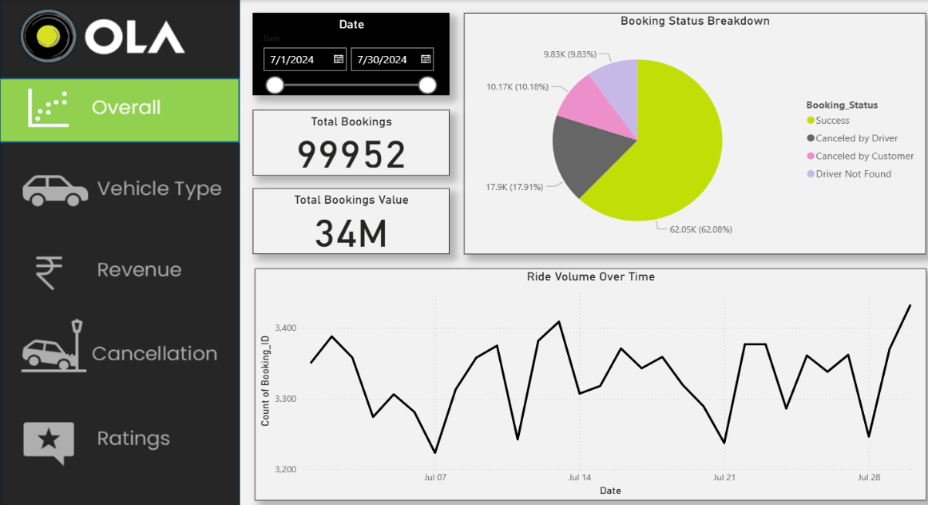

2. Vehicle Type
- Top 5 Vehicle Types by Ride Distance
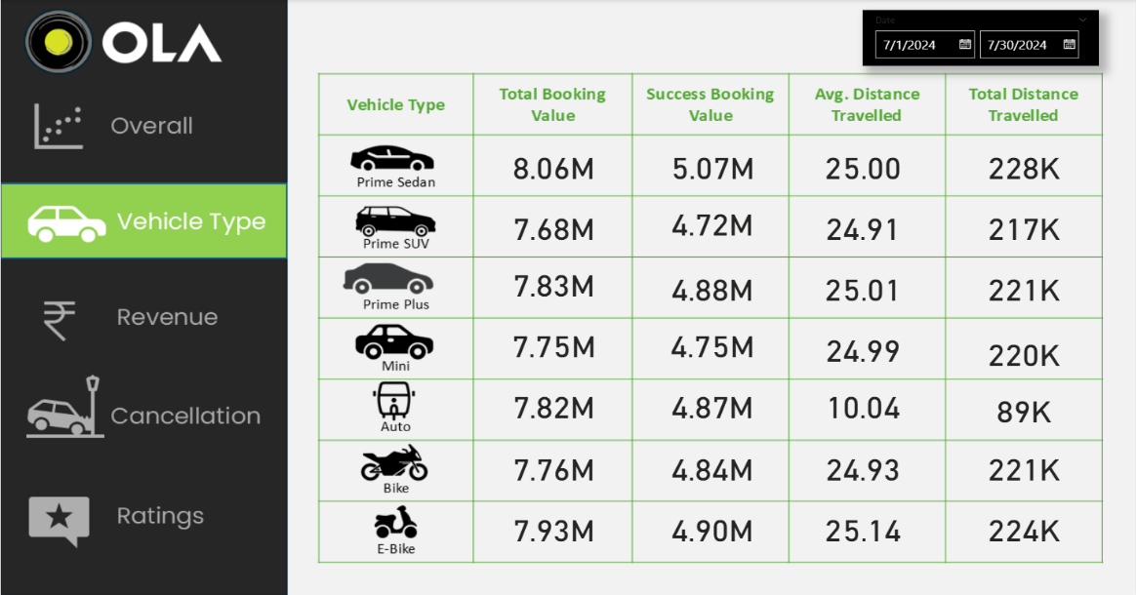

3. Revenue
- Revenue by Payment Method
- Top 5 Customers by Total Booking Value
- Ride Distance Distribution Per Day
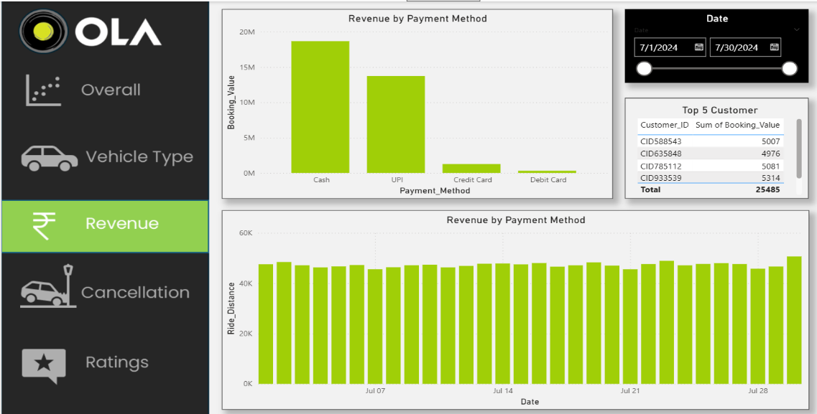

4. Cancellation
- Cancelled Rides Reasons (Customer)
- Cancelled Rides Reasons(Drivers)
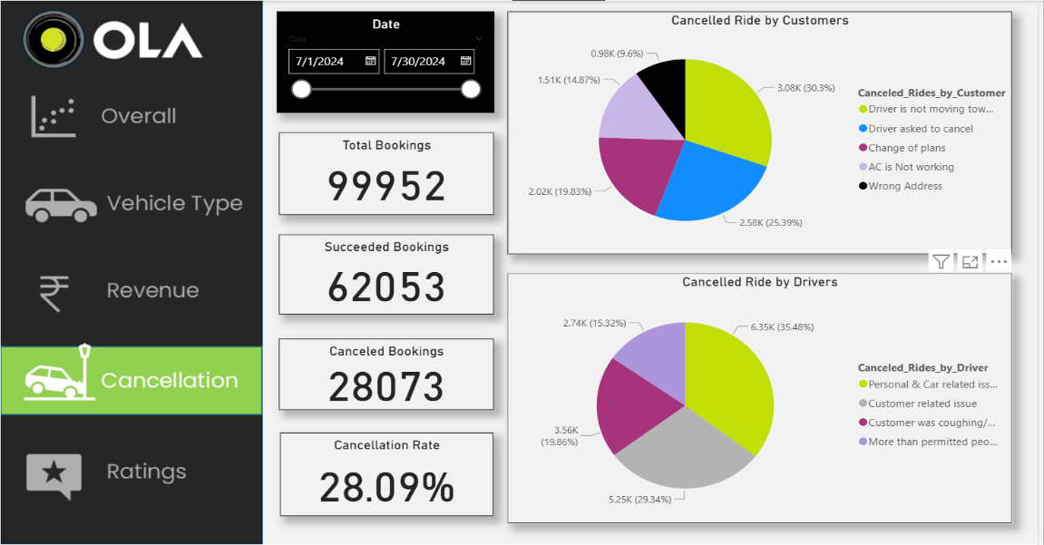

5. Ratings
  - Driver Ratings
  - Customer Ratings
